**Bug №1**

**Priority:** Immediate

**Severity:** Blocker

**Summary:**

[Mobile] Meizu: The footer isn’t displayed on the page.

**Description:**

[Mobile] Meizu: The footer isn’t displayed on the page.

**Steps to reproduce:**

1. Open the site <https://radacode.com/>
2. Pay attention to the page.

**Actual result:**

The footer isn’t displayed on the page.

**Expected result:**

The footer is displayed on the page.

**Additional information:**

Also, the description (“.NET outsourcing provider”) of the company isn’t displayed on the page.

Mobile: Meizu MX5

OS: Android 5.1

**Attached files:** [**bag\_1.png**](bag_1.png)

**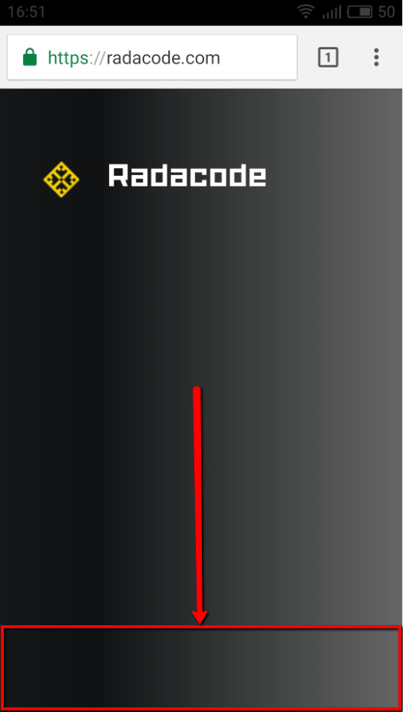**

**Bug №2**

**Priority:** High

**Severity:** Normal

**Summary:**

“404” error is displayed on the page when trying to go to “<https://radacode.com/contacts>“ link.

**Description:**

“404” error is displayed on the page when trying to go to “<https://radacode.com/contacts>“ link

from the browser. The link isn’t accessible directly from the address bar.

**Steps to reproduce:**

1. Open the link “<https://radacode.com/contacts>”
2. Pay attention to the page.

**Actual result:**

“404” error is displayed on the page when trying to go to “<https://radacode.com/contacts>“ link.

**Expected result:**

The “<https://radacode.com/contacts>” link is accessible directly from the address bar.

**Additional information:**

OS: Windows 8

Browsers: Google Chrome 57, Mozilla Firefox 52, IE 10

**Attached files:** [**bug\_2.png**](bug_2.png)

**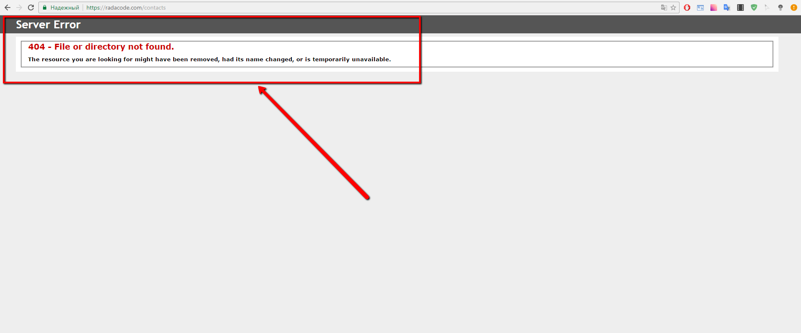**

**Bug №3**

**Priority:** Medium

**Severity:** Minor

**Summary:**

The vertical scroll is displayed on the right side of the page

**Description:**

The vertical scroll is displayed on the right side of the page

**Steps to reproduce:**

1. Open the site <https://radacode.com/>
2. Pay attention to the right side of the page

**Actual result:**

The vertical scroll is displayed on the right side of the page

**Expected result:**

The vertical scroll isn’t displayed on the right side of the page

**Additional information:**

OS: Windows 8

Browsers: Google Chrome 57, Mozilla Firefox 52, IE 10

**Attached files:** [**bug\_3.png**](bug_3.png)

**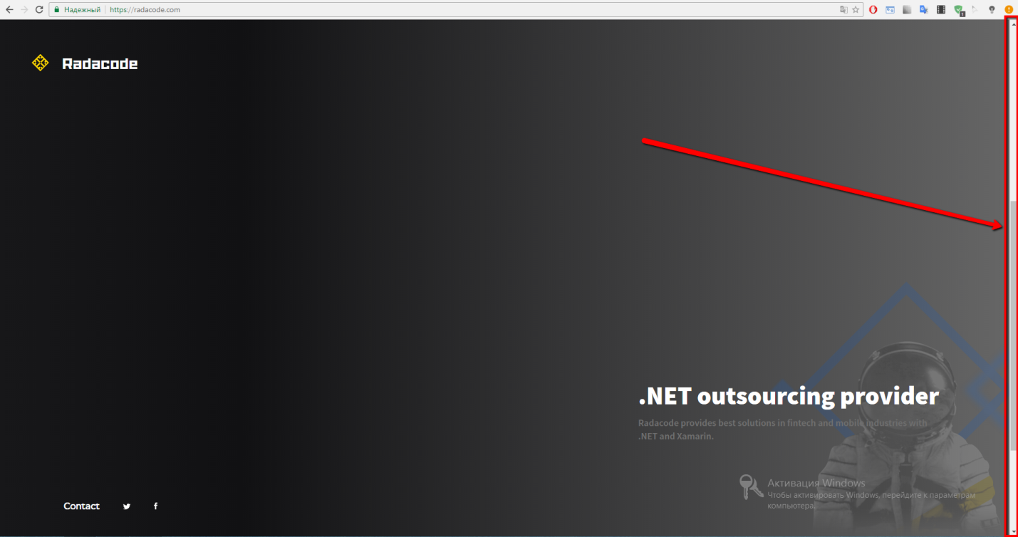**

**Bug №4**

**Priority:** Medium

**Severity:** Trivial

**Summary:**

The text “Contacts” isn’t underlined fully on the Contacts page.

**Description:**

The text “Contacts” isn’t underlined fully on the Contacts page.

**Steps to reproduce:**

1. Open the site <https://radacode.com/>
2. Go to the footer
3. Click the “Contact” button
4. Pay attention to the text “Contacts”

**Actual result:**

The text “Contacts” isn’t underlined fully on the Contacts page.

**Expected result:**

The text “Contacts” is underlined fully on the Contacts page.

**Additional information:**

OS: Windows 8

Browsers: Google Chrome 57, Mozilla Firefox 52, IE 10

**Attached files:** [**bug\_4.png**](bug_4.png)

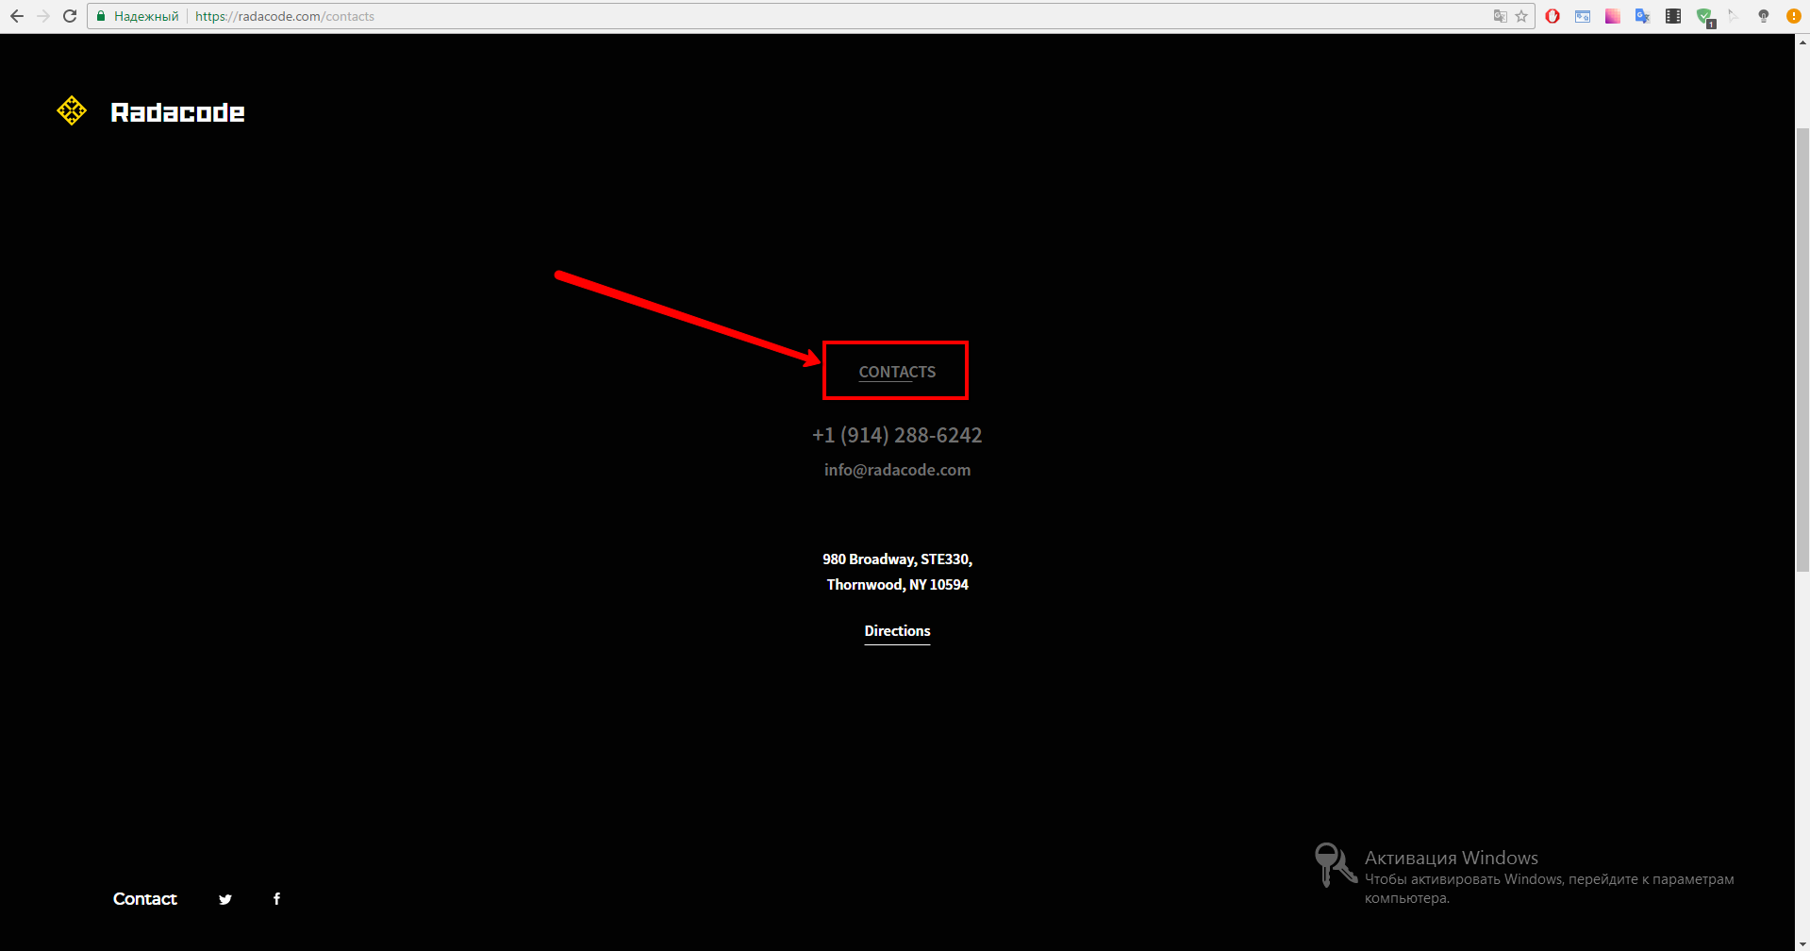

**Bug №5**

**Priority:** Medium

**Severity:** Trivial

**Summary:**

The color of the text “Radacode provides best solutions…” merges with the background of the main page.

**Description:**

The color of the text “Radacode provides best solutions in fintech and mobile industries with .NET and XAMARIN” merges with the background of the main page.

**Steps to reproduce:**

1. Open the site <https://radacode.com/>
2. Go to the bottom right side of the page
3. Pay attention to the text “Radacode provides best solutions in fintech and mobile industries with .NET and XAMARIN”

**Actual result:**

The text “Contacts” isn’t underlined fully on the Contacts page.

**Expected result:**

The text “Contacts” is underlined fully on the Contacts page.

**Additional information:**

OS: Windows 8

Browsers: Google Chrome 57, Mozilla Firefox 52, IE 10

**Attached files:<bug_5.png>**

**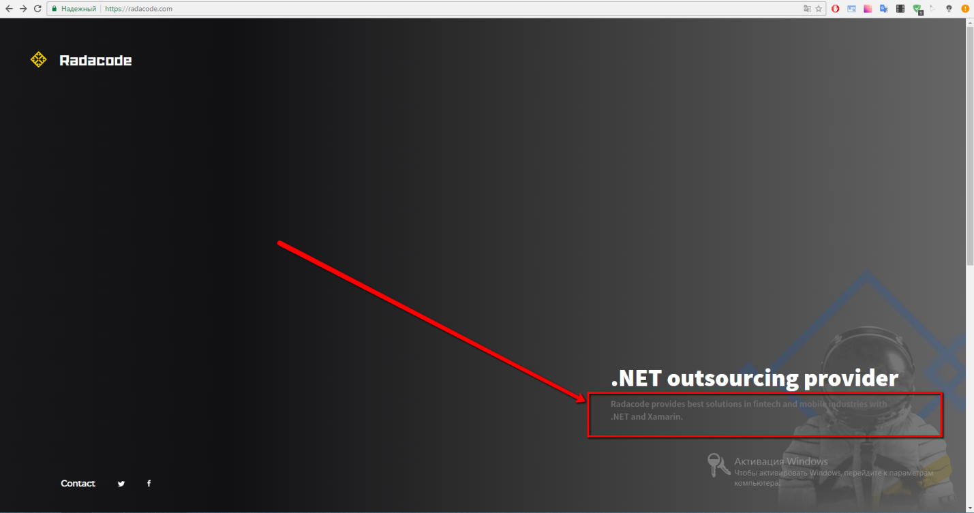**

**Bug №6**

**Priority:** Medium

**Severity:** Minor

**Summary:**

The facebook page is opened at the same tab after clicking the “Facebook” button

**Description:**

The facebook page is opened at the same tab after clicking the “Facebook” button.

**Steps to reproduce:**

1. Open the site <https://radacode.com/>
2. Go to the footer
3. Click the “Facebook” button
4. Pay attention to the page tab of the browser

**Actual result:**

The facebook page is opened at the same tab after clicking the “Facebook” button

**Expected result:**

The facebook page is opened at the new tab after clicking the “Facebook” button

**Additional information:**

The same problem with the “Twitter” button in the footer of the main page

OS: Windows 8

Browsers: Google Chrome 57, Mozilla Firefox 52, IE 10

**Attached files:**

[**bug\_6.png**](bug_6.png)

**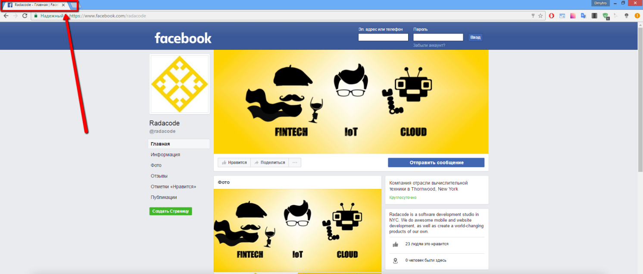**

**Bug №7**

**Priority:** High

**Severity:** Trivial

**Summary:**

The telephone number, address, email are placed in the same row at the “Contact” page

**Description:**

The telephone number, address, email are placed in the same row at the “Contact” page

**Steps to reproduce:**

1. Open the site <https://radacode.com/>
2. Go to the footer
3. Click the “Contact” button
4. Pay attention to the contact information

**Actual result:**

The telephone number, address, email are placed in the same row at the “Contact” page

**Expected result:**

The telephone number, address, email are placed in different rows at the “Contact” page

**Additional information:**

Also, the text “Contacts” and the “Directions” button aren’t aligned horizontally at the same block

OS: Windows 8

Browsers: IE 10

**Attached files:**

[**bug\_07.png**](bug_07.png)

**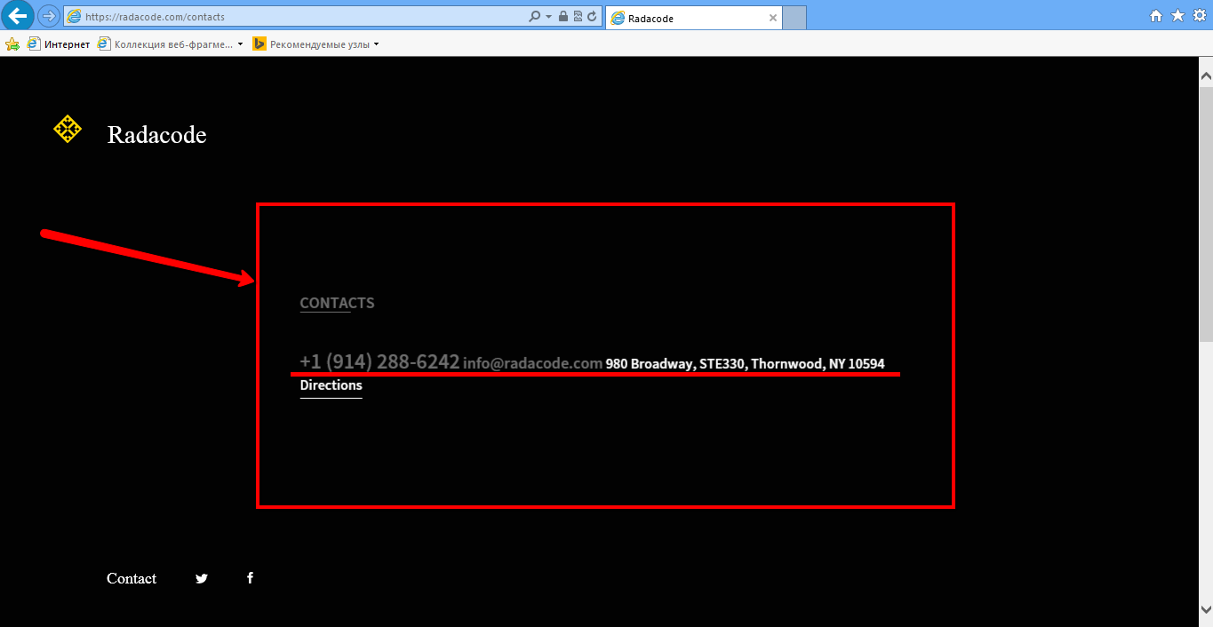**

**Bug №8**

**Priority:** Low

**Severity:** Trivial

**Summary:**

The tooltip isn’t displayed above the Twitter button during hovering the Twitter button.

**Description:**

The tooltip isn’t displayed above the Twitter button during hovering the Twitter button.

**Steps to reproduce:**

1. Open the site <https://radacode.com/>
2. Go to the footer
3. Hover the cursor over the “Twitter” button
4. Pay attention to the “Twitter” button

**Actual result:**

The tooltip isn’t displayed above the Twitter button during hovering the Twitter button.

**Expected result:**

The tooltip is displayed above the Twitter button during hovering the Twitter button.

**Additional information:**

The same problem with the “Facebook” button in the footer of the main page.

OS: Windows 8

Browsers: Google Chrome 57, Mozilla Firefox 52, IE 10

**Attached files:**

[**bug\_07.png**](bug_07.png)

**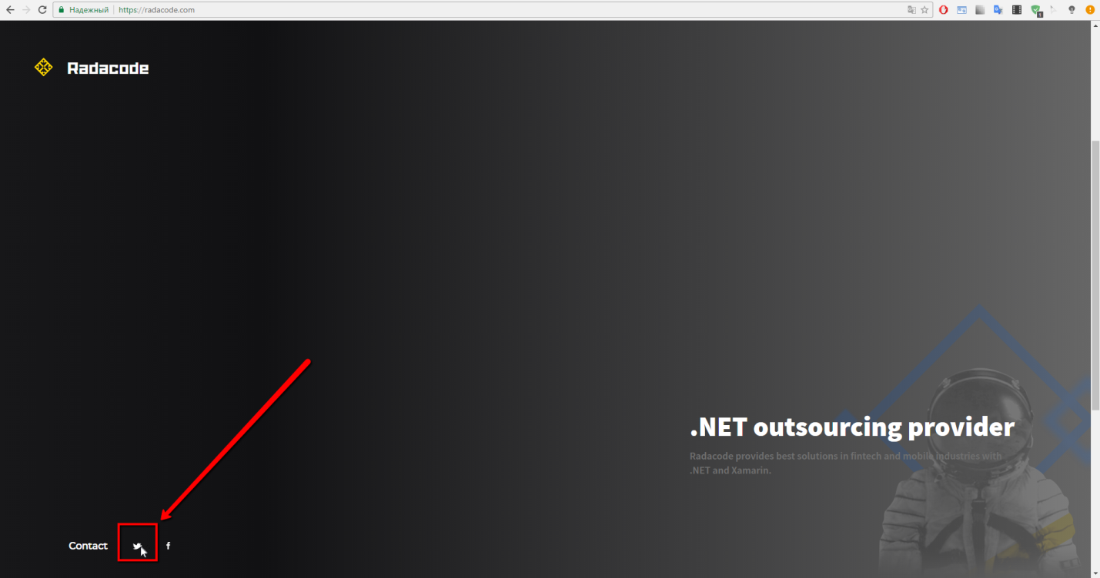**

**Bug №9**

**Priority:** Low

**Severity:** Trivial

**Summary:**

The “Contact” button in the footer isn’t highlighted after hovering the cursor.

**Description:**

The “Contact” button in the footer isn’t highlighted after hovering the cursor.

**Steps to reproduce:**

1. Open the site <https://radacode.com/>
2. Go to the footer
3. Hover the cursor over the “Contact” button
4. Pay attention to the “Contact” button

**Actual result:**

The “Contact” button in the footer isn’t highlighted after hovering the cursor.

**Expected result:**

The “Contact” button in the footer is highlighted after hovering the cursor.

**Additional information:**

The same problem with the “Twitter” and “Facebook” buttons in the footer of the main page.

OS: Windows 8

Browsers: Google Chrome 57, Mozilla Firefox 52, IE 10

**Attached files:**[**bug\_09.png**](bug_09.png)

**